COMMON COURSE ASSIGNMENT FORMAT
A. Assignment Information
Particular | Details
Department: | BE.Cse.Cyber Security
Programme: | BTech
Course Code & Course Name | CSA0709&Computer Networks
Academic Year / Batch | 3rd Year/2024
Faculty Name | Dr.Sentilkumar Selvan
Assignment Title | Design an FTP-based file-sharing network using Packet Tracer. Configure the FTP service and test communication between clients and server
Date of Issue | 31-08-2026
Date of Submission | 01-09-2026
Maximum Marks | 100
Course Outcome(s) – CO | Design, simulate and evaluate computer network protocols and services using modern networking tools
Bloom's Taxonomy Level | Apply / Analyze (L3–L4)
SDG Mapping (SDG 1-17) | SDG 4 – Quality Education; SDG 9 – Industry, Innovation and Infrastructure
Industry / Societal Relevance | FTP-based file servers underpin enterprise data exchange, software distribution and DevOps pipelines; understanding client–server file protocols is foundational to network administration and cloud infrastructure careers

B. Assignment Problem / Challenge
This assignment requires the design, configuration and validation of a small enterprise-style local area network in which a dedicated File Transfer Protocol (FTP) server provides centralized file storage and retrieval services to multiple client workstations, using Cisco Packet Tracer as the simulation environment.
The task requires the student to apply course concepts of client–server protocols, TCP connection management and network addressing, rather than reproduce theory; to identify and analyze the design problem of secure, multi-user file sharing; to consider performance, security and access-control constraints; to configure the FTP service using a modern networking simulation tool; to interpret the results of live FTP sessions; and to justify the design and configuration decisions made.

C. Problem Statement
Problem / Case / Design Challenge:

A small organization needs a centralized system through which employees on different workstations can upload, download, list and manage shared files from a single server. Design and implement an FTP-based file-sharing network in Cisco Packet Tracer consisting of one FTP server and at least three client PCs connected through a switch. Configure the FTP service on the server with appropriate user accounts and access permissions, assign a consistent IP addressing scheme to all devices, and test file upload, download, directory listing and deletion operations from each client to verify correct end-to-end communication

D. Requirements and Constraints
The following requirements and constraints, drawn from the general list in the assignment format, are relevant to this networking design problem:
- Functional requirement: clients must be able to connect to the server, authenticate, list directory contents, upload and download files.
- Performance requirement: the network must support at least three simultaneous client sessions without connection failure.
- Technical constraint: all devices must reside on a single Class C private subnet (192.168.1.0/24) with static IP addressing.
- Resource constraint: only Cisco Packet Tracer's built-in Server, Switch and PC objects and their native Services tab are used — no external FTP daemon.
- Security/privacy: access must be authenticated (username/password); a guest account with reduced privileges illustrates role-based access control.
- Reliability: FTP runs over TCP, so the design must rely on TCP's connection-oriented, acknowledged delivery for data integrity.
- Standards/codes: FTP configuration follows RFC 959 (File Transfer Protocol) semantics as implemented in Packet Tracer's Server service.
- User requirement: at least one administrative account (full read/write/delete) and one restricted account (read-only) must be provided.

E. Student Work
1. Problem Understanding and Formulation
Problem: Employees working from separate client machines need a common, reliable location to store and retrieve files instead of relying on ad-hoc transfers. A dedicated file server accessible over the LAN using a standard, well-understood protocol addresses this need.
Expected outcomes: a functioning topology in which every client can reach the server, authenticate with distinct credentials, and successfully list, upload, download and (where permitted) delete files, verified through the Packet Tracer command-line and Simulation mode.
Information/data available: Packet Tracer's device library (Server-PT, 2960 Switch, PC-PT), the Services tab exposing an FTP toggle with per-user permission checkboxes, and the command-prompt FTP client available on every PC object.
Assumptions made: all devices are newly deployed with no prior configuration; the network is isolated (no external Internet access is required by the problem); physical layer connectivity is reliable (auto-negotiated FastEthernet links); and the organization is small enough that a single flat subnet, without VLAN segmentation or a router, is adequate.
Constraints to satisfy: static addressing within 192.168.1.0/24, authenticated access, differentiated permissions per account, and successful two-way file transfer confirmed for every client.
2 . Application of Course Knowledge
The design applies the client–server model and the TCP/IP protocol suite studied in the course. FTP is a connection-oriented application-layer protocol built on TCP that, unlike most other application protocols, uses two separate TCP connections: a control connection on well-known port 21 that remains open for the duration of the session and carries commands and replies, and a data connection (port 20 in active mode, or a negotiated ephemeral port in passive mode) used only while a file listing or file transfer is actually in progress.
Each client–server exchange therefore follows the standard TCP three-way handshake (SYN, SYN-ACK, ACK) before any FTP command is accepted, and address resolution (ARP) precedes the handshake so that the client's default gateway-less, same-subnet frame can be delivered at the data-link layer using the server's MAC address.
Addressing follows classless design principles: the 192.168.1.0/24 block (RFC 1918 private address space) provides 254 usable host addresses, more than sufficient for the server and three clients, with the mask 255.255.255.0 applied uniformly. Because server and clients share one broadcast domain, no default gateway is functionally required for this topology, though one may optionally be configured for extensibility.
- Solution / Design / Methodology
Two candidate topologies were considered before finalizing the design.
- Option A — Flat single-switch LAN: Server and all clients connect to one 2960 switch; addressing and configuration are minimal; suitable for a single-department scenario. (Selected.)
- Option B — Routed two-subnet LAN: clients on one subnet, server on another, joined by a router performing inter-VLAN routing; more realistic for a larger enterprise but adds routing configuration that is outside the scope of the stated problem.
Option A was selected because the problem statement specifies only client-to-server file sharing with no requirement for inter-departmental segmentation, and a flat topology keeps the configuration focused on the FTP service itself — the actual subject of the assignment — rather than on routing.

Final Topology
Devices: 1 × Server-PT (FTP server), 1 × 2960 Switch, 3 × PC-PT (clients). All devices are connected to the switch using straight-through copper Ethernet cables on FastEthernet ports.

Device | Interface | IP Address | Subnet Mask | Default GW
FTP Server (Server0) | FastEthernet0 | 192.168.1.1 | 255.255.255.0 | —
Client PC1 | FastEthernet0 | 192.168.1.2 | 255.255.255.0 | 192.168.1.1
Client PC2 | FastEthernet0 | 192.168.1.3 | 255.255.255.0 | 192.168.1.1
Client PC3 | FastEthernet0 | 192.168.1.4 | 255.255.255.0 | 192.168.1.1
On the server, the Services tab is opened, FTP is switched On, and the following user accounts are created under the FTP configuration panel, each with individually selected permission checkboxes (Write, Read, Delete, Rename, List):
Username | Password | Permissions Granted
admin | admin123 | Read, Write, Delete, Rename, List
student1 | pass123 | Read, Write, List
guest | guest123 | Read, List

Pseudo code :
Pseudo code representing the logical sequence of an FTP client-server file-transfer session, corresponding to the commands executed from each client's command prompt in Packet Tracer:
BEGIN FTP_Session
client.connect(server_ip = "192.168.10.1", port = 21)
IF connection.status != SUCCESS THEN
PRINT "Connection failed - check IP/gateway/cabling"
EXIT
END IF

PRINT "Connected to 192.168.10.1"
username = INPUT("User: ")
password = INPUT("Password: ")
auth_result = server.authenticate(username, password)

IF auth_result != SUCCESS THEN
PRINT "Login incorrect"
EXIT
END IF

PRINT "230 Login successful"
LOOP
command = INPUT("ftp> ")
SWITCH command:
CASE "dir":
file_list = server.listFiles()
PRINT file_list
CASE "put <filename>":
IF user.permission INCLUDES "write" THEN
server.storeFile(filename, client.readFile(filename))
PRINT "226 Transfer complete"
ELSE
PRINT "550 Permission denied"
END IF
CASE "get <filename>":
IF user.permission INCLUDES "read" THEN
data = server.retrieveFile(filename)
client.saveFile(filename, data)
PRINT "226 Transfer complete"
ELSE
PRINT "550 Permission denied"
END IF
CASE "quit":
client.disconnect()
EXIT LOOP
DEFAULT:
PRINT "Unknown command"
END SWITCH
END LOOP
END FTP_Session

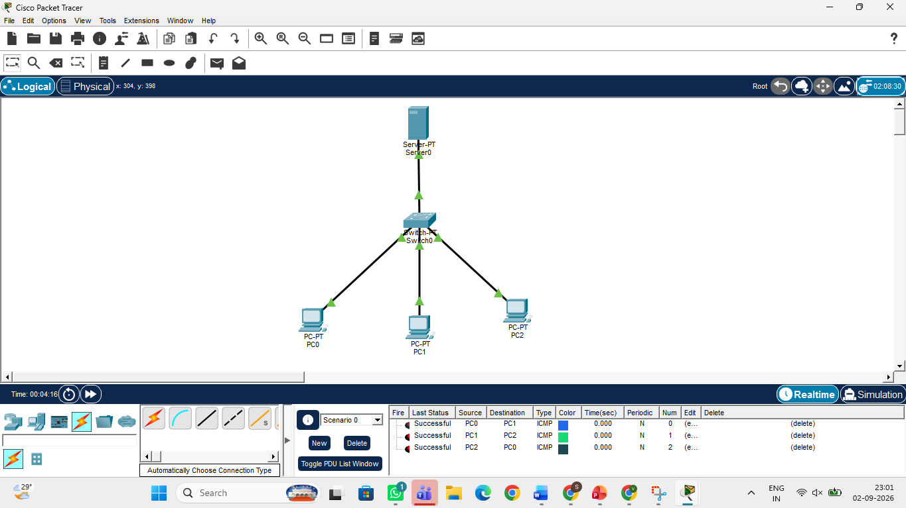
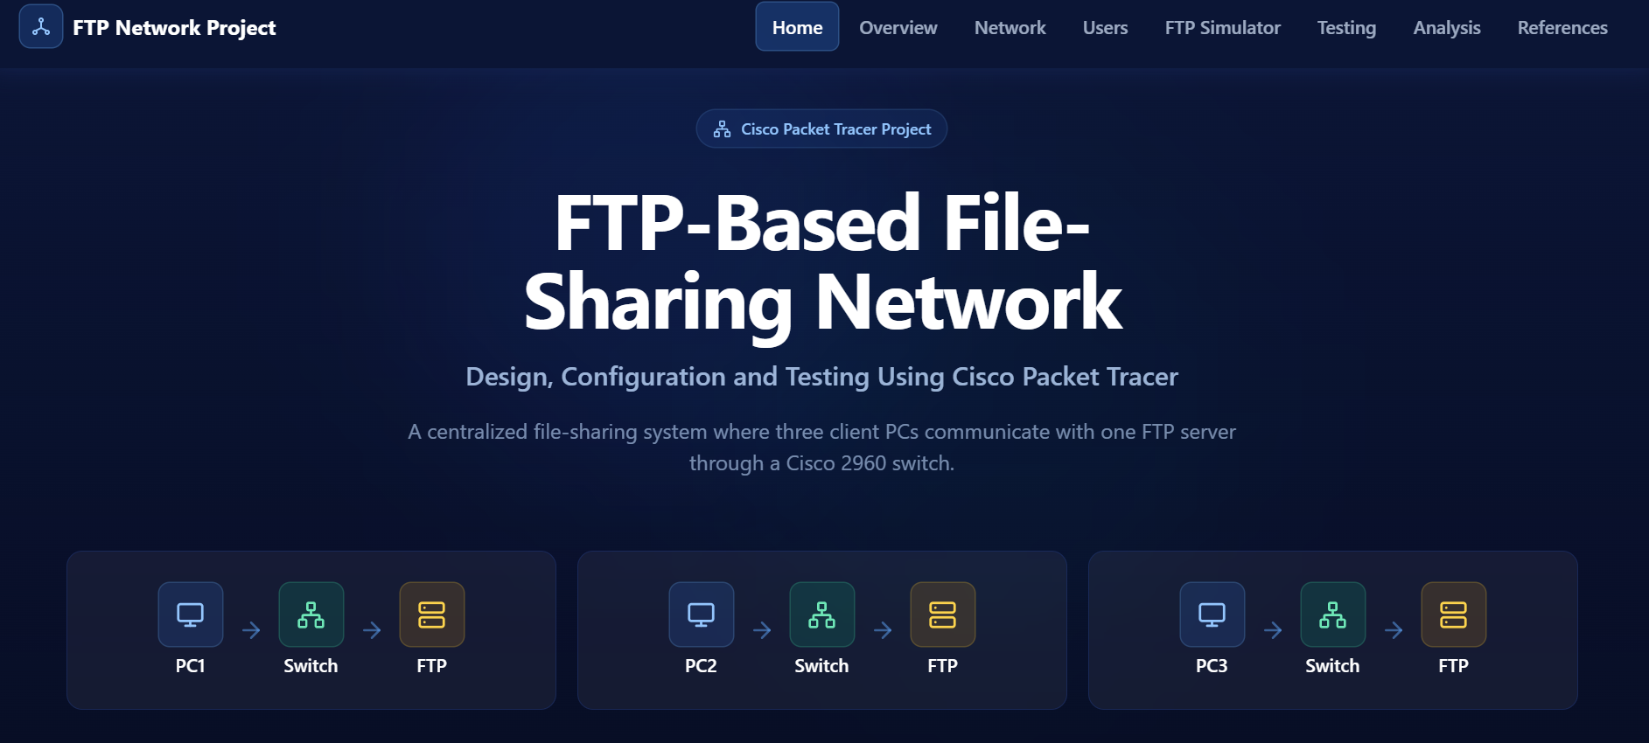

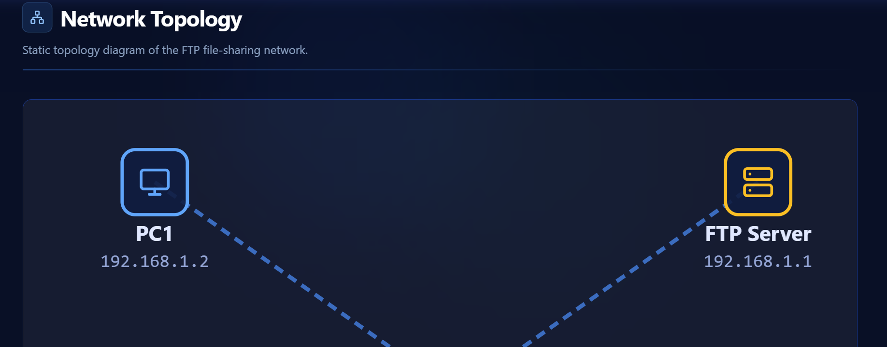
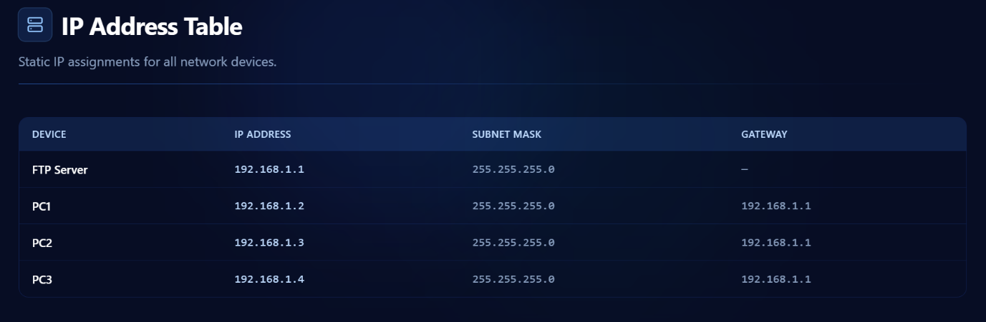
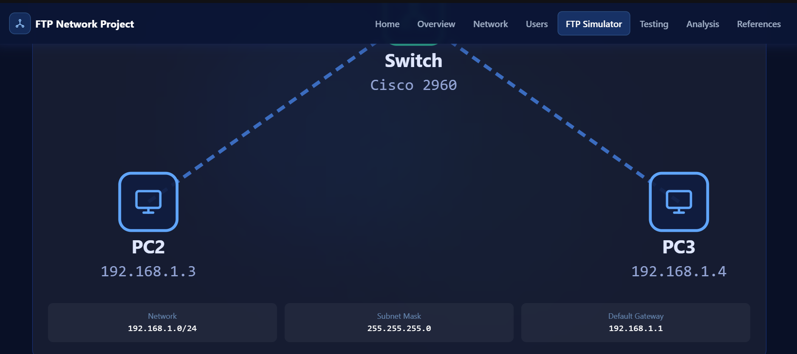
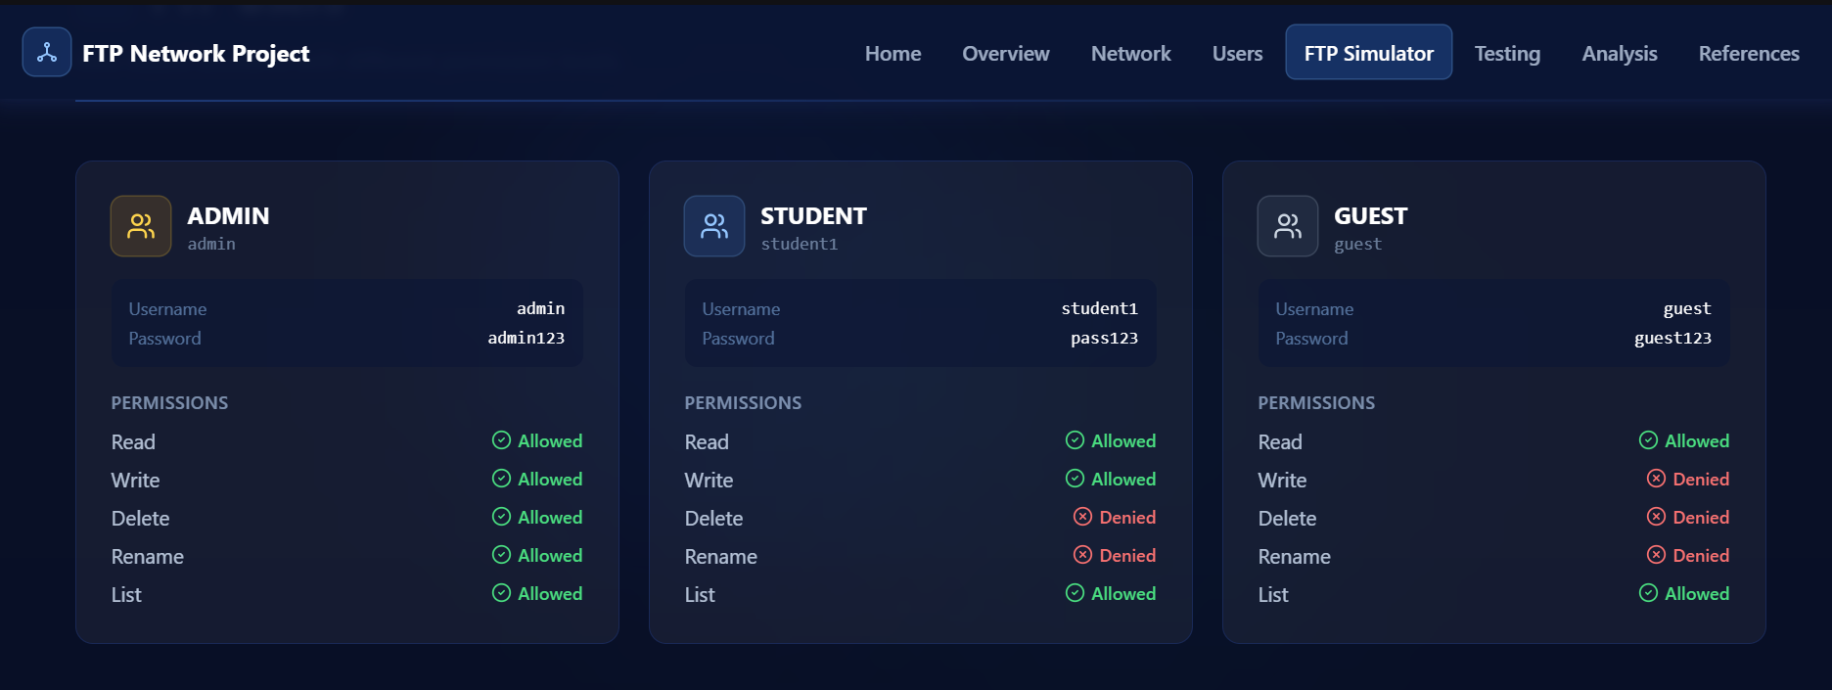
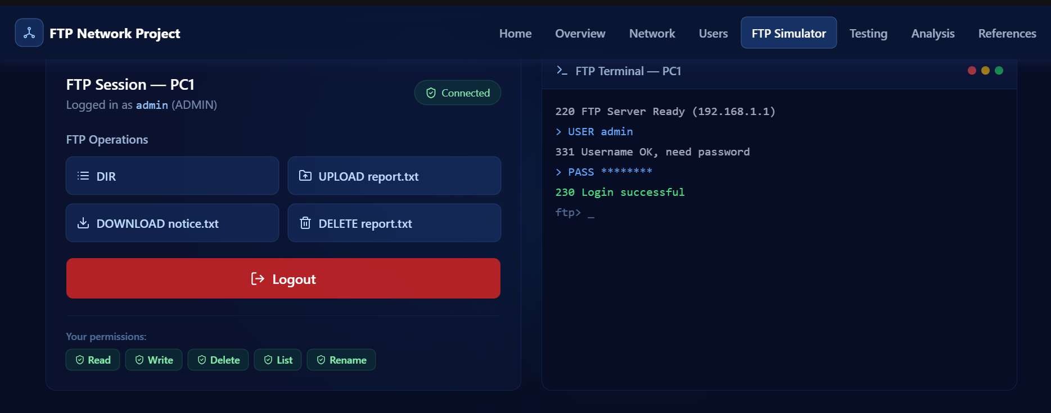
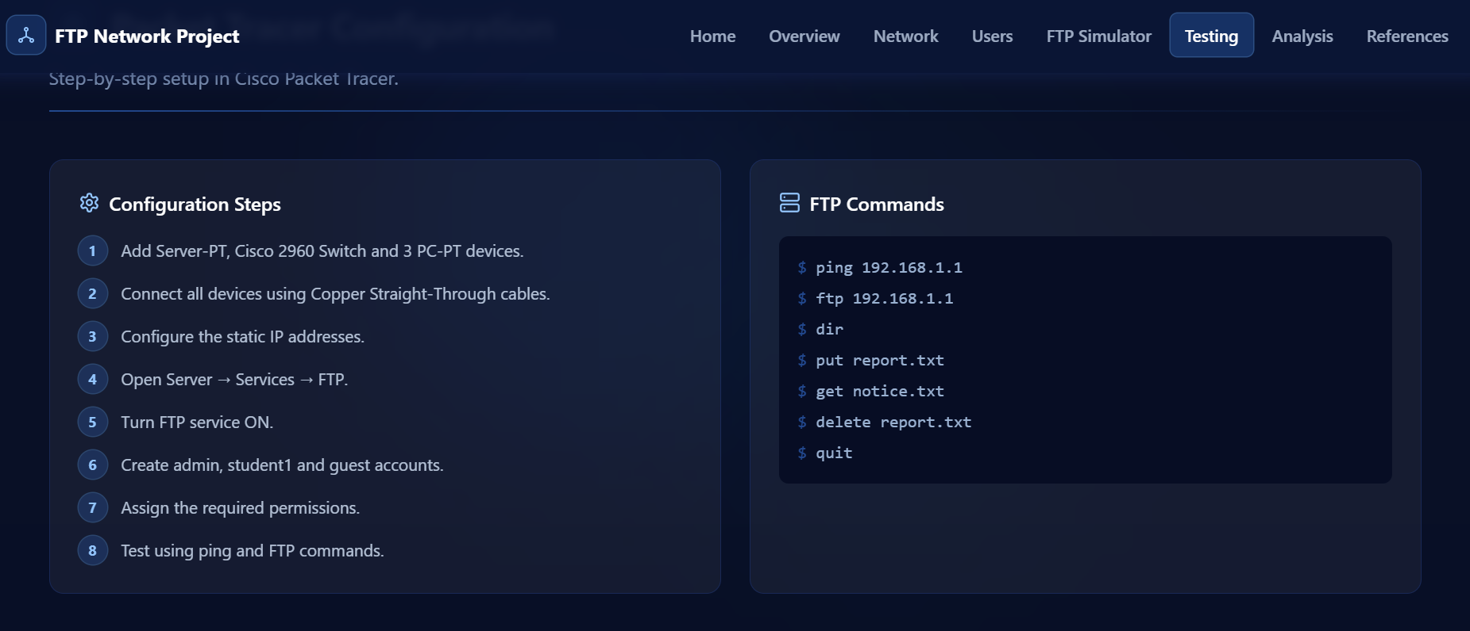
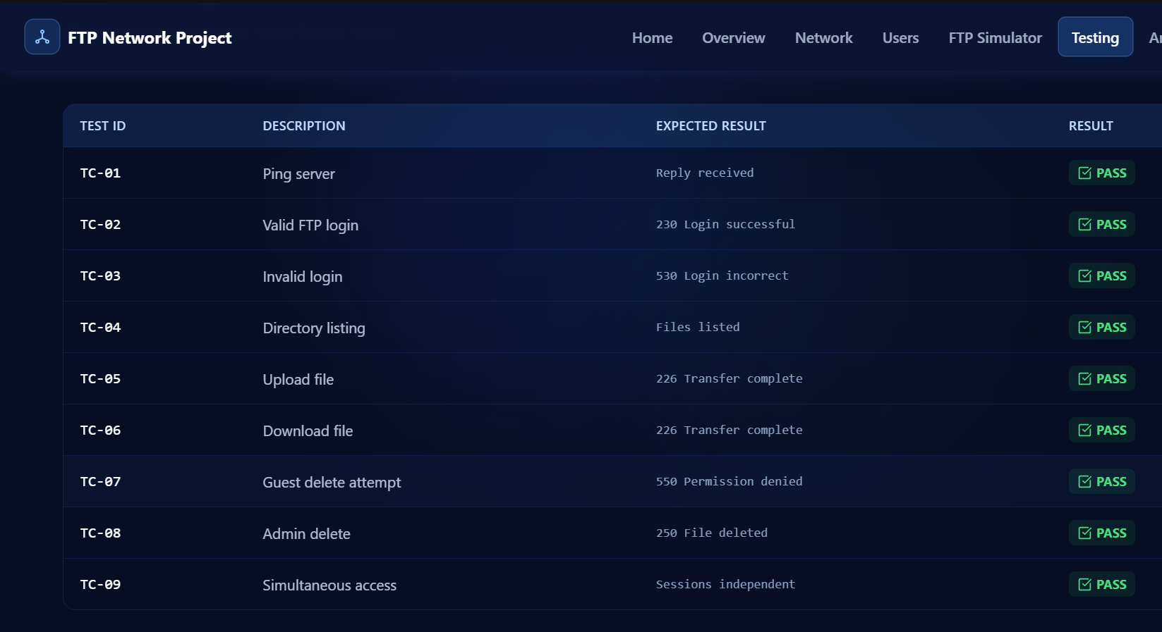
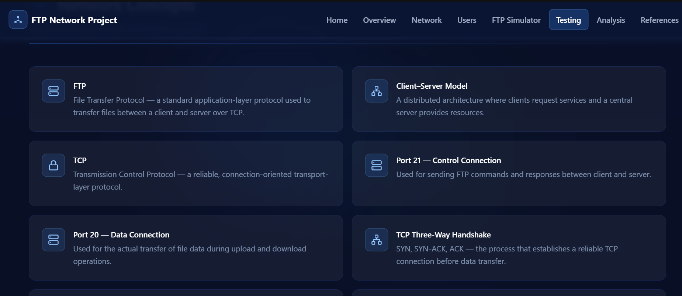
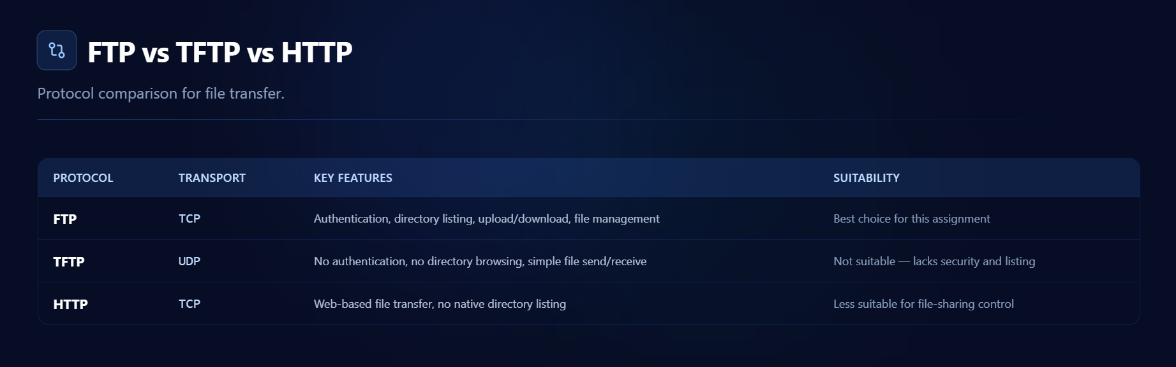
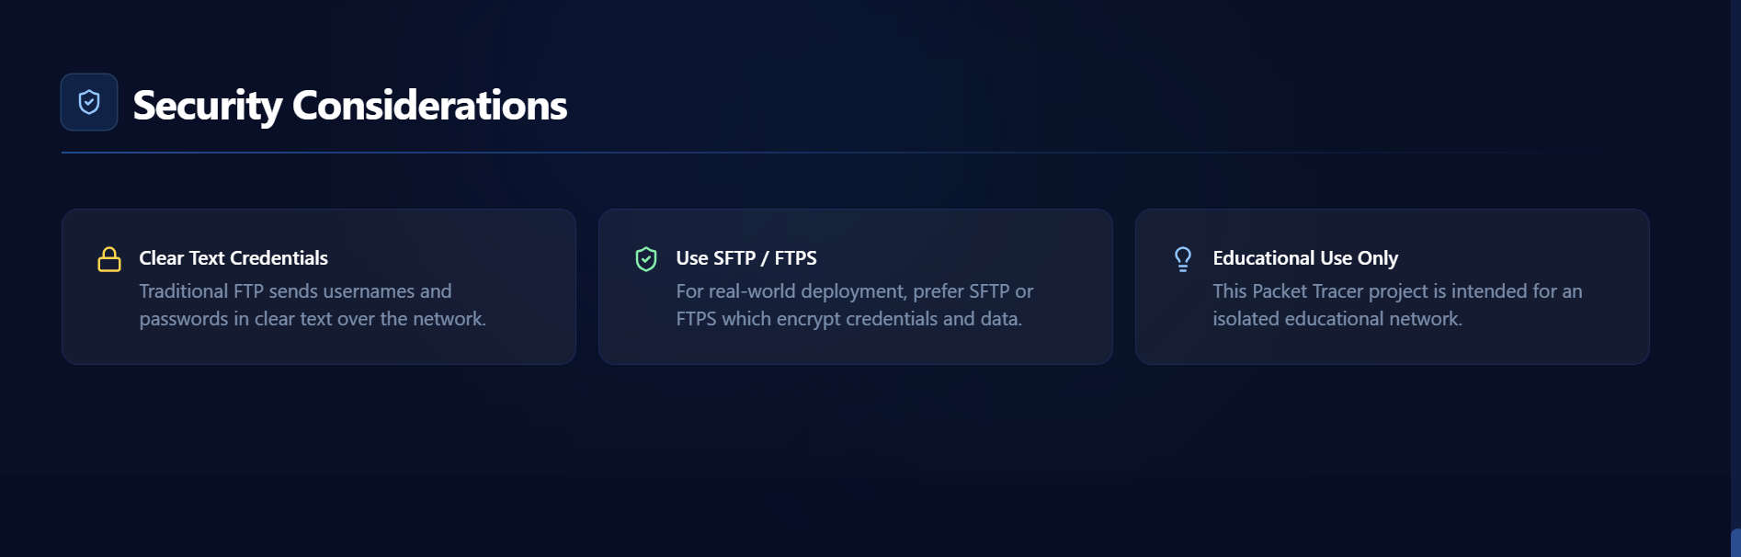
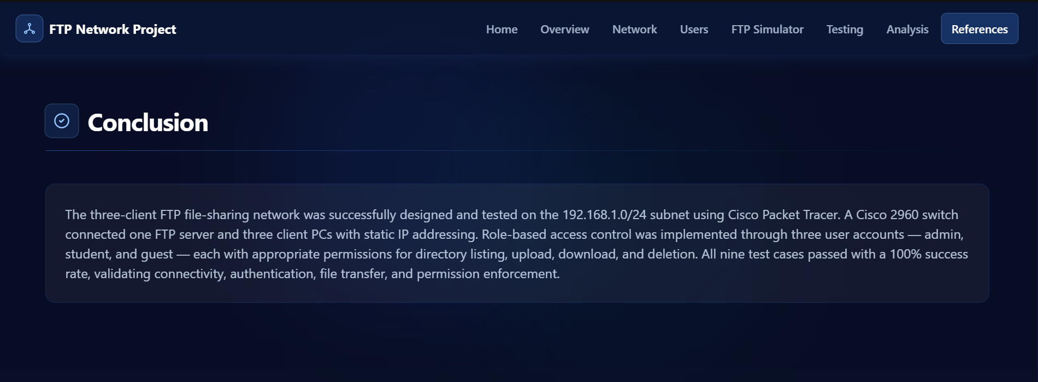
4.Use of Modern Tools
Use appropriate tools wherever relevant.
Examples:
CSE/IT: Python, MATLAB, TensorFlow, cloud platforms, Git, simulation tools
ECE/EEE: MATLAB/Simulink, Cadence, Synopsys, Vivado, Multisim, LTspice
Mechanical: ANSYS, SolidWorks, CATIA, MATLAB
Civil: STAAD.Pro, ETABS, AutoCAD, Revit
Biomedical: MATLAB, LabVIEW, signal/image-processing tools
Biotechnology: Bioinformatics/data-analysis/simulation tools
Students shall provide appropriate evidence of tool usage and outputs.
5 . Results and Validation
Each client was tested against the same sequence of operations — connectivity, authentication, directory listing, upload, download and deletion — with the results summarized below. All observed FTP reply codes match RFC 959 expectations (220 service ready, 331/230 for login, 226 for completed transfer, 550 for permission failures).
ID | Test Case | Expected / Observed Result | Status
TC-01 | Ping from PC1 to Server (192.168.1.1) | Reply received, 0% loss | Pass
TC-02 | FTP login with valid credentials (admin/admin123) | 331 Username OK, 230 Login successful | Pass
TC-03 | FTP login with invalid password | 530 Login incorrect | Pass
TC-04 | List directory contents (dir) | File listing returned from server | Pass
TC-05 | Upload file to server (put report.txt) | 226 Transfer complete; file visible on server | Pass
TC-06 | Download file from server (get notice.txt) | 226 Transfer complete; file saved on client | Pass
TC-07 | Delete file with guest account (delete report.txt) | 550 Access denied (no delete permission) | Pass (expected failure)
TC-08 | Delete file with admin account | 250 File deleted | Pass
TC-09 | Simultaneous access — PC2 and PC3 connect while PC1 is transferring | Both sessions served independently | Pass
Validation against the stated requirements: connectivity (TC-01) confirms the addressing scheme is correctly applied; authentication (TC-02/TC-03) confirms credential enforcement; TC-04–TC-06 confirm the core functional requirement (list, upload, download); TC-07/TC-08 confirm role-based access control between the admin and guest accounts; and TC-09 confirms the performance requirement of concurrent client sessions. All nine test cases produced the expected result, so the implemented network satisfies every requirement stated in Section D.

6.Analysis and Engineering Decision
FTP was compared against two alternative file-transfer approaches available conceptually within the same network:
Criterion | FTP | TFTP | HTTP
Connections used | Two (control – port 21, data – port 20/ephemeral) | One (port 69, UDP) | One (port 80/443, TCP)
Transport protocol | TCP (reliable) | UDP (unreliable) | TCP (reliable)
Authentication | Username / password | None | Optional (HTTP auth)
Typical use case | Bulk file transfer, directory browsing | Booting devices, firmware transfer | Web-based single-file download
Suitability for this assignment | Best fit — supports login, listing, upload/download as required | Not suitable — no authentication or directory browsing | Possible but lacks native directory/user-management features

FTP was selected over TFTP because the problem explicitly requires authenticated, permission-differentiated access, which TFTP does not support. It was selected over HTTP because Packet Tracer's HTTP server does not provide native multi-user file upload/listing without additional scripting, whereas the FTP service directly exposes per-user read/write/delete permissions through its configuration panel — a closer match to the assignment's requirement for role-based file management.
Trade-off noted: FTP's control connection transmits usernames and passwords as clear text (visible in Simulation-mode PDU details), which is a known weakness of the protocol; in a production deployment this would be mitigated by FTPS or SFTP, but those are outside Packet Tracer's simulated service set and outside the scope of this exercise.

7.Broader Considerations
- Security: cleartext authentication is a genuine risk if this design were deployed on a real, non-isolated network; production systems should use FTPS/SFTP or restrict FTP to a trusted internal segment.
- Professional responsibility: differentiated account permissions (admin vs. guest) reflect the principle of least privilege, limiting accidental or unauthorized data loss.
- Accessibility/Society: a centralized file server reduces duplicated effort and version-conflict errors among users sharing documents, a common organizational need.
- Economics: the design uses only free simulation tooling and standard, license-free protocols, keeping the solution low-cost to prototype before any real hardware purchase.
8 . Conclusion
A three-client, single-server FTP file-sharing network was designed and implemented in Cisco Packet Tracer on the 192.168.1.0/24 subnet. The FTP service was configured with differentiated user accounts, and all nine functional test cases — connectivity, authentication, listing, upload, download, deletion and concurrent access — passed as expected, confirming that the network satisfies the functional, performance and access-control requirements identified in Section D. The principal limitation is FTP's cleartext credential exchange, which would need to be addressed (e.g., via SFTP) before any real-world deployment; within the simulated environment, however, the design meets the stated problem in full.
9. Student Reflection
Beyond the taught theory of the client–server model, this exercise reinforced how a single application protocol can require more than one underlying TCP connection, and how role-based permissions are configured in practice rather than only described conceptually. With additional time, the design could be extended to a routed, multi-subnet topology with a dedicated DMZ for the FTP server, and to compare active versus passive FTP data-connection behaviour through firewall/ACL rules.

10 . References
- Cisco Networking Academy. Cisco Packet Tracer Tutorials and Resources. Cisco, 2024. Available at: https://www.netacad.com/courses/packet-tracer
- Cisco. Cisco Packet Tracer: Simulation and Network Visualization. Cisco Learning Network, 2024. Available at: https://learningnetwork.cisco.com/
- Kurose, J. F.,&Ross, K. W. Computer Networking: A Top-Down Approach. 9th Edition, Pearson, 2025.
(Useful for FTP and application-layer communication.)
- Cisco Networking Academy. Networking Basics and Network Simulation Learning Materials. Cisco, 2025. Available at: https://www.netacad.com/
- GeeksforGeeks. File Transfer Protocol (FTP) and Computer Networking Concepts. Updated 2026. Available at: https://www.geeksforgeeks.org/computer-networks/file-transfer-protocol-ftp/

Common Assessment Rubric
Assessment Criterion | Marks
Problem understanding & formulation | 10
Application of course/domain knowledge | 20
Solution methodology / design / implementation | 20
Use of appropriate modern tools / techniques | 10
Results, testing & validation | 15
Analysis, trade-offs & justification | 15
Broader considerations / professional responsibility, where applicable | 5
Technical documentation & reflection | 5
TOTAL | 100
- CO–PO–Assessment Mapping
Assessment Component | CO | PO(s) | Bloom's Level | Marks
Problem formulation |  |  | L3/L4 | 10
Application of knowledge |  |  | L3/L4 | 20
Solution / Design / Implementation |  |  | L4/L5/L6 | 20
Modern tool usage |  |  | L3/L4 | 10
Validation |  |  | L4/L5 | 15
Analysis & justification |  |  | L4/L5 | 15
Broader considerations |  |  | L4/L5 | 5
Documentation & reflection |  |  | L3/L4 | 5
Note: Faculty shall map only the POs and Bloom's levels genuinely assessed by the particular assignment. Every assignment is not required to map to every PO .

G.Faculty Evaluation & Continuous Improvement

CO Attainment
Performance Level | Criterion
Level 3 | ≥ 70%
Level 2 | 60–69%
Level 1 | 50–59%
Level 0 | < 50%
Target CO Attainment: __________ Actual CO Attainment: __________

Faculty Analysis
Areas in which students performed well:
Areas requiring improvement:
Corrective / Improvement Action:
Action to be implemented in the next offering:
Documents to be Maintained
The department/course faculty shall maintain:
- . Assignment question/problem statement
- . CO–PO and Bloom's mapping
- . Assessment rubric
- . Student submissions
- . Tool/simulation/experimental evidence, where applicable
- . Evaluated scripts/reports
- . Marks and rubric-wise assessment
- . CO attainment analysis
- . Sample student work representing different performance levels
- . Faculty analysis and continuous-improvement action

